Step 1: Log into Canvas (as an instructor).
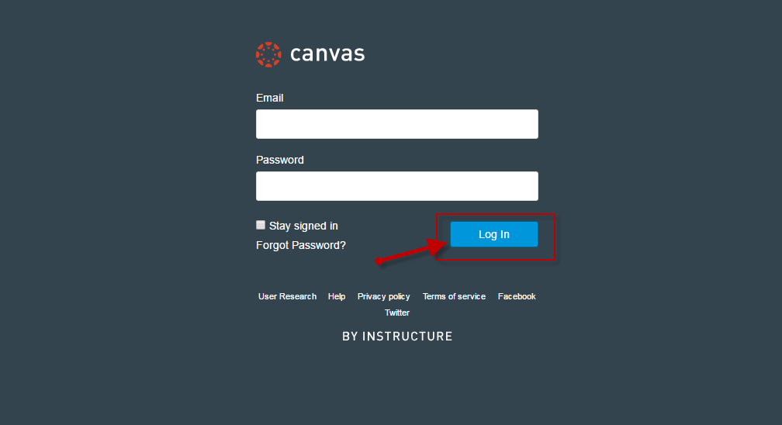

Step 2: Under Courses, locate and enter Canvas course.
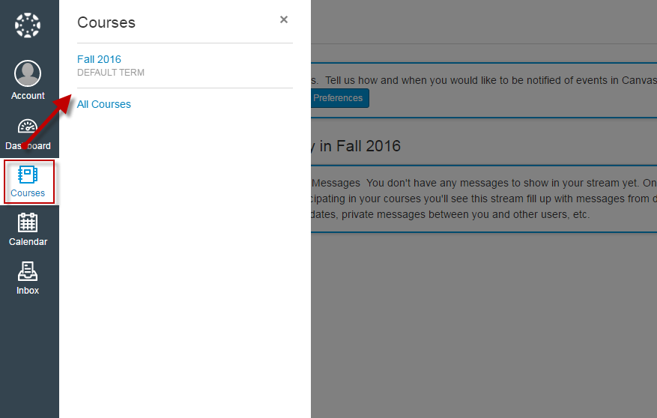
Step 3: On Canvas course home page, locate and click on the McGraw Hill Connect link (located via the course navigation menu).
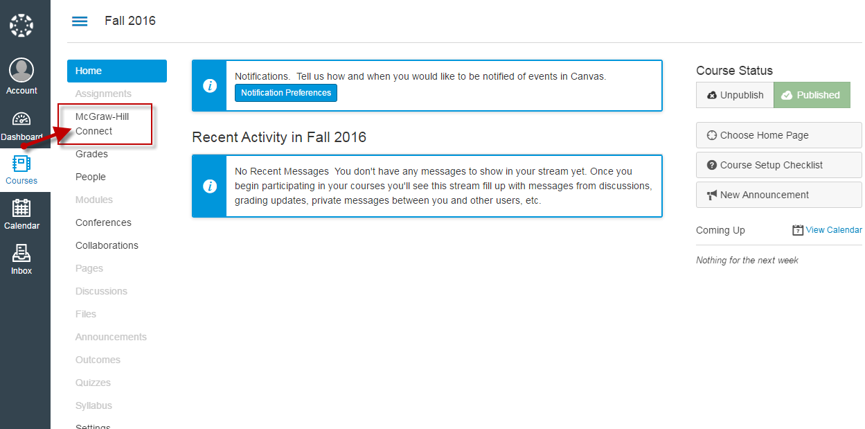

Step 4: Click Authorize (prompted upon first launch only).
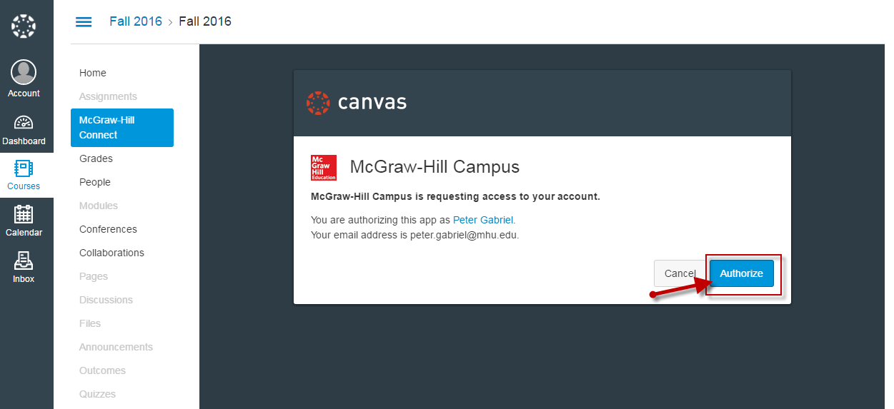

Step 5: Click on Begin.
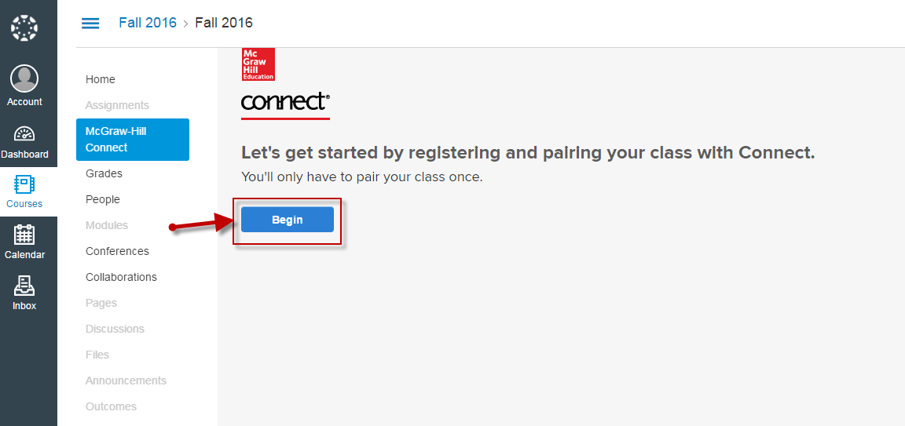

Step 6: Click Continue.
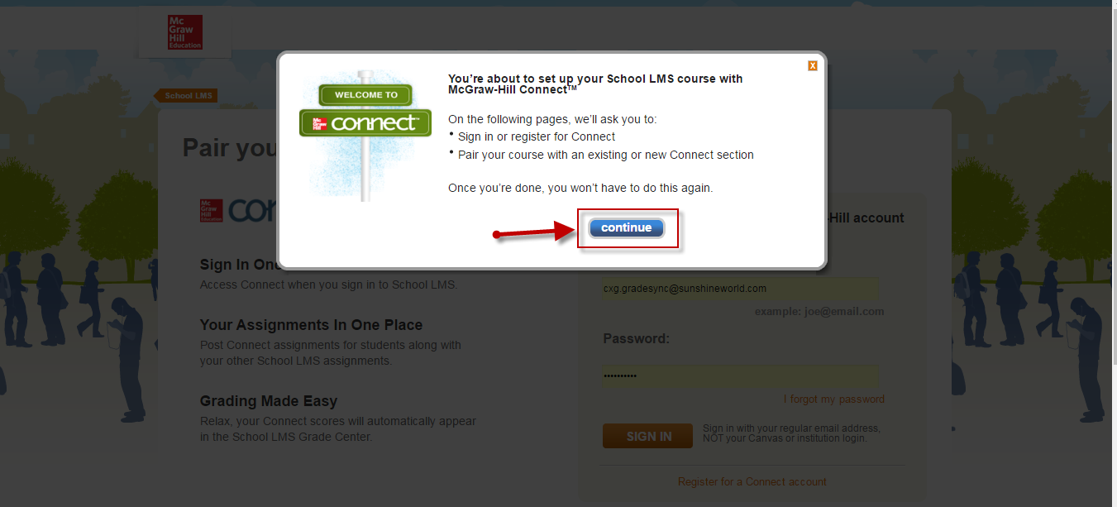

Step 7: If a new Connect user, click on Register for a Connect account
*If an existing Connect user, enter your Connect email address (username) and password; click Sign In.
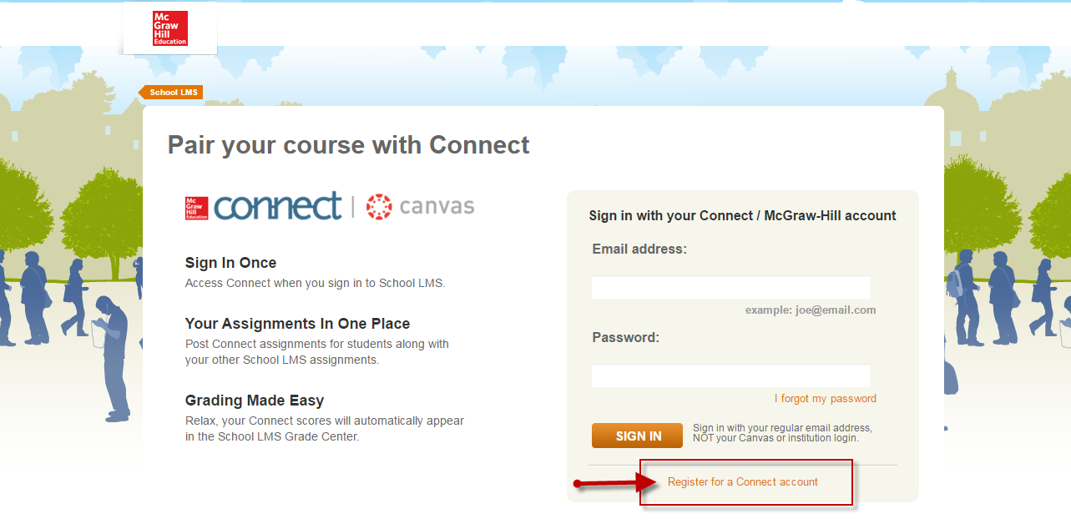

Step 8: Enter all required information, accept the Terms of Use; click Finish
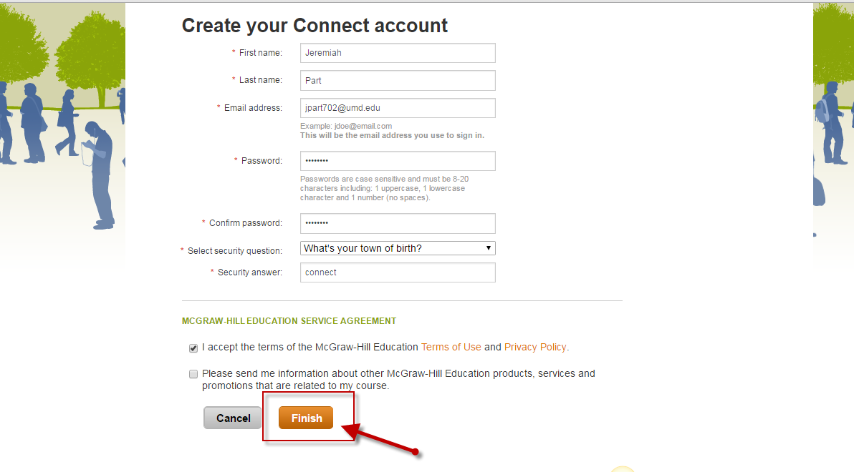
Step 9: To locate your Connect title, search by Connect title, author, or subject.
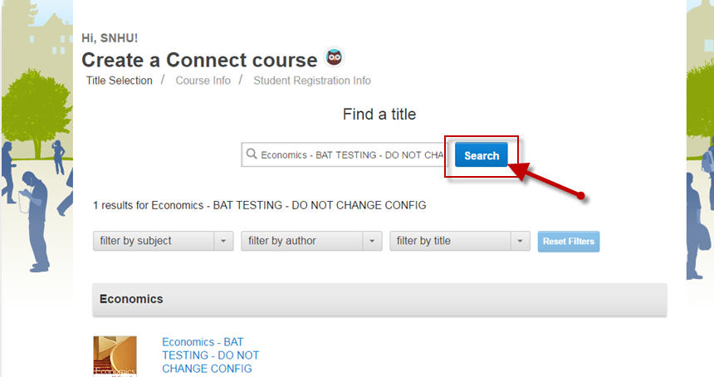

Step 10: After locating your Connect title, select the appropriate product.
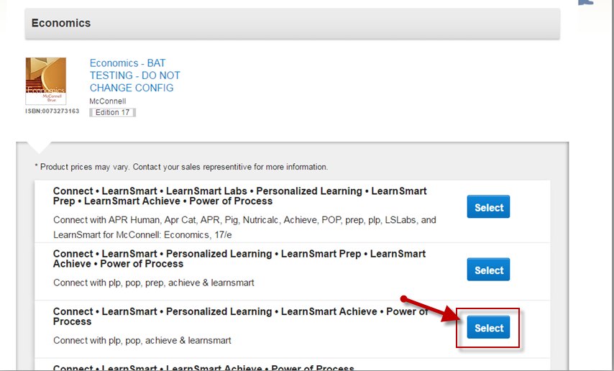

Step 11: Enter course and section name; then, click on Create Course
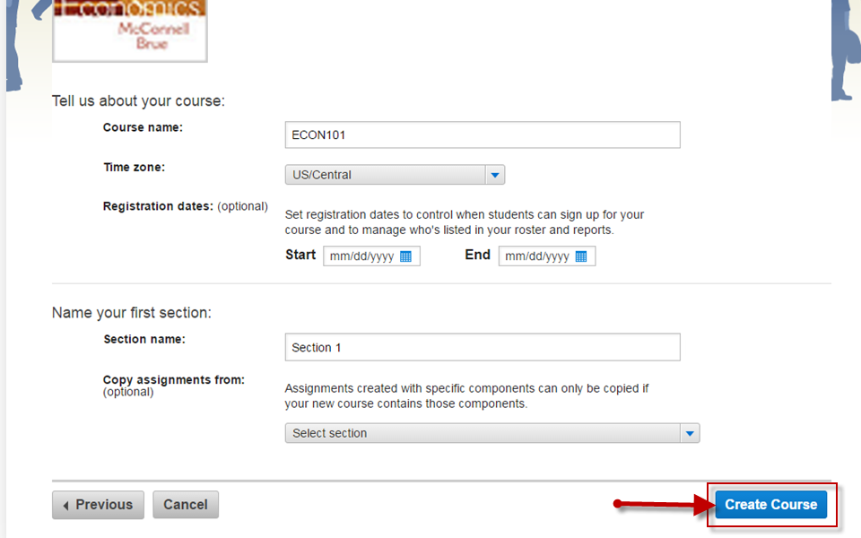
Step 11: Your Canvas-Connect course has been paired. Once you receive pairing confirmation, click go to section home page in order to begin using Connect
*If pairing an existing Connect course/section, you will receive a similar confirmation message.
