Step 1: Log into Canvas (as a student).
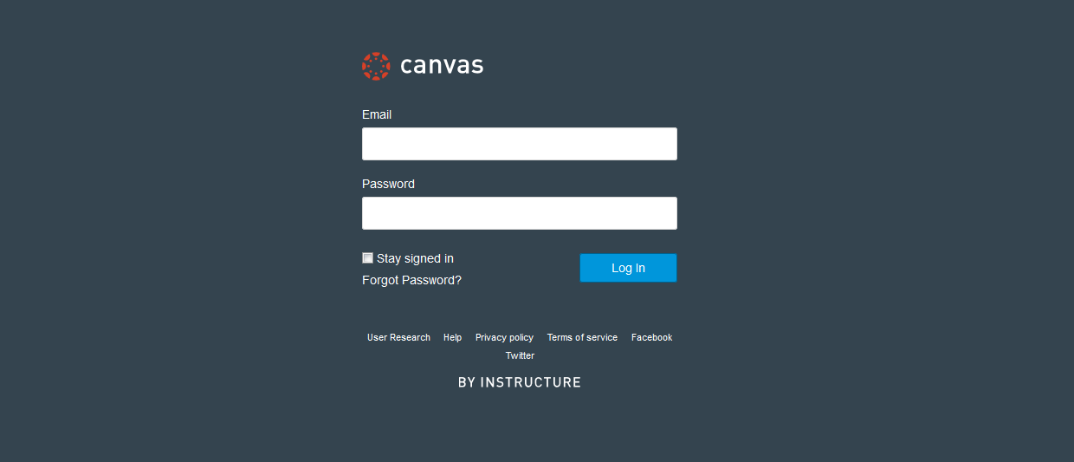

Step 2: Under Courses, locate and enter Canvas course.
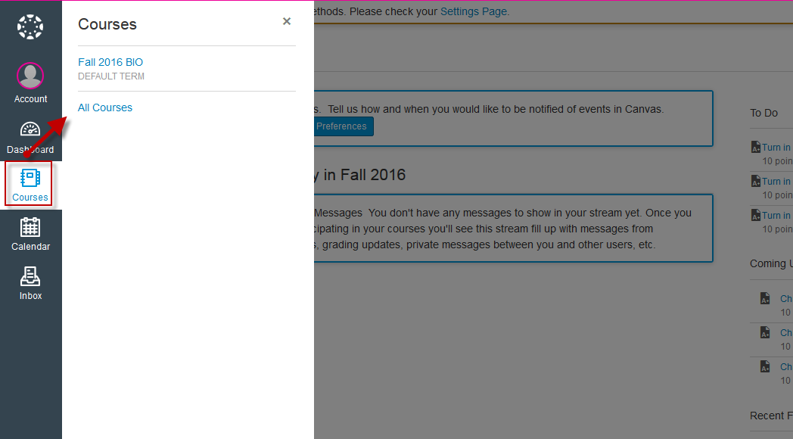

Step 3: On Canvas course home page, locate and click on the Connect deep integration link (via course navigation menu).
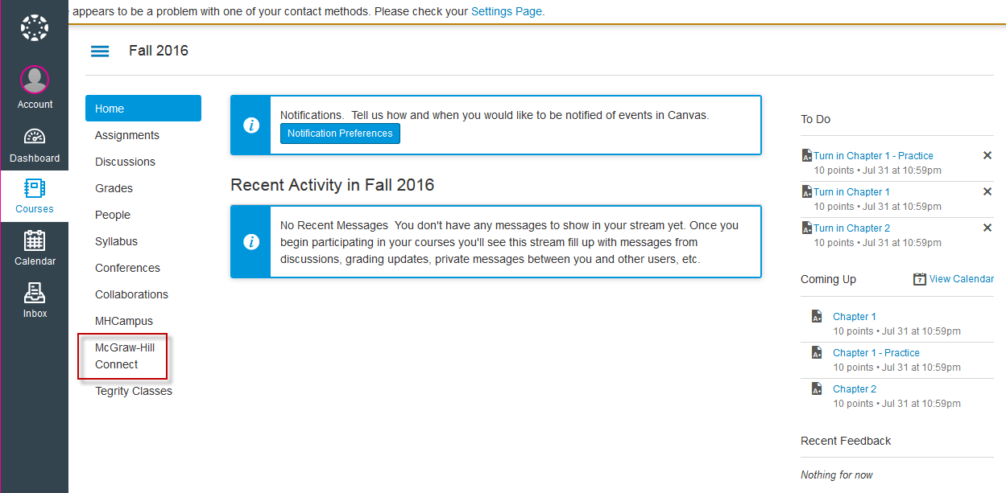

Step 4: Click on Begin.
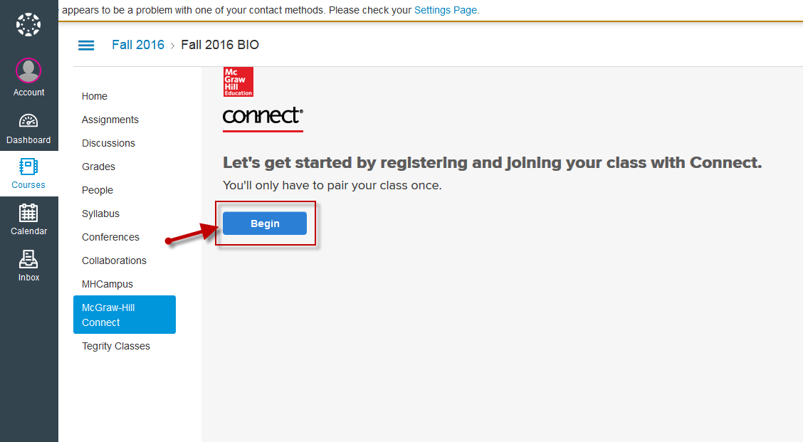

Step 5: If a new Connect user, click on Register.
*If an existing Connect user, enter your Connect email address (username) and password; click Sign In.
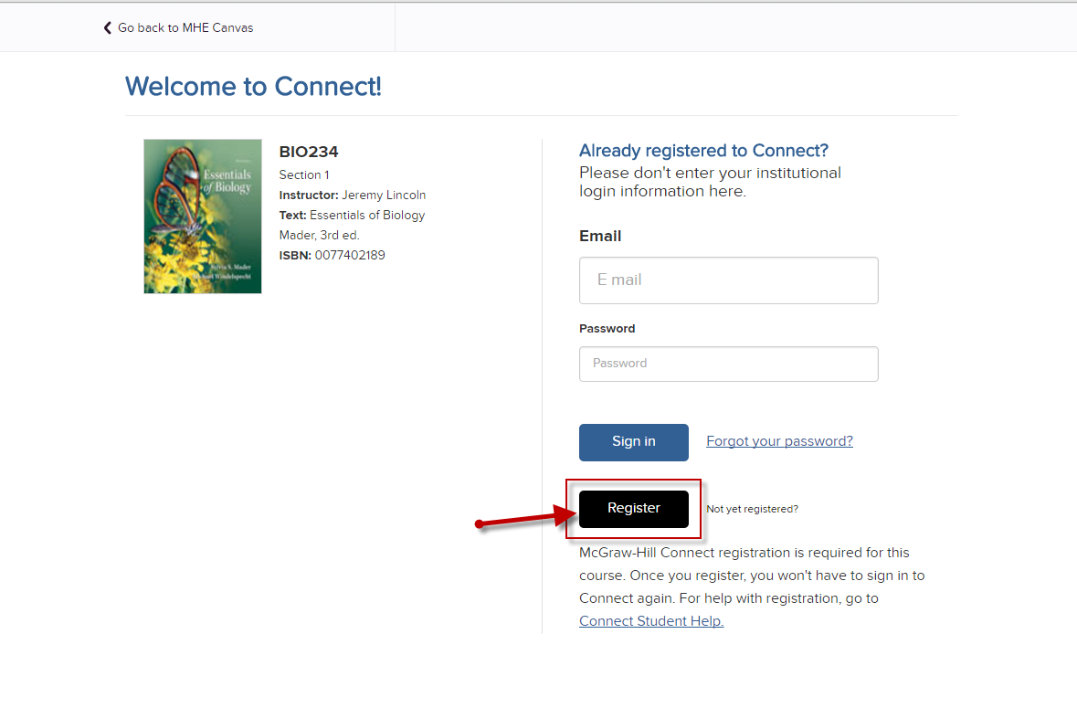

Step 6: Enter email address and click Begin.
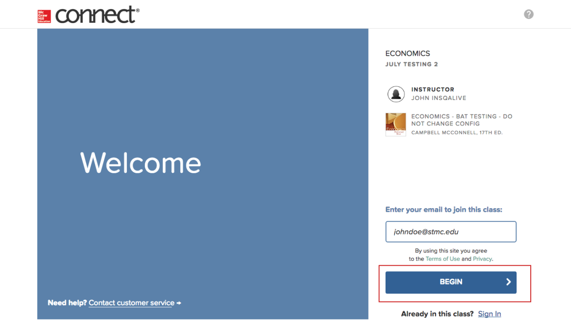

Step 7: Enter in all required information; then, click Next Step.
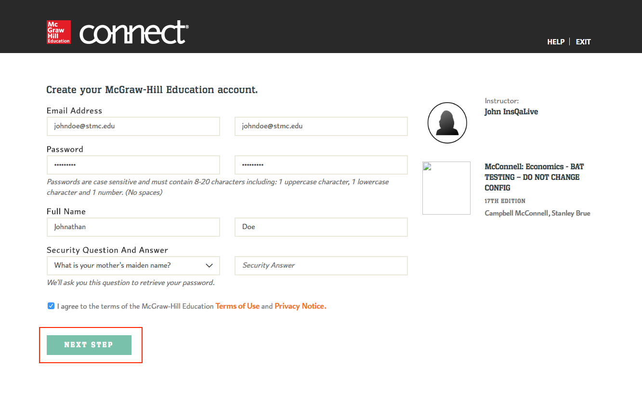

Step 8: Select the appropriate registration option.
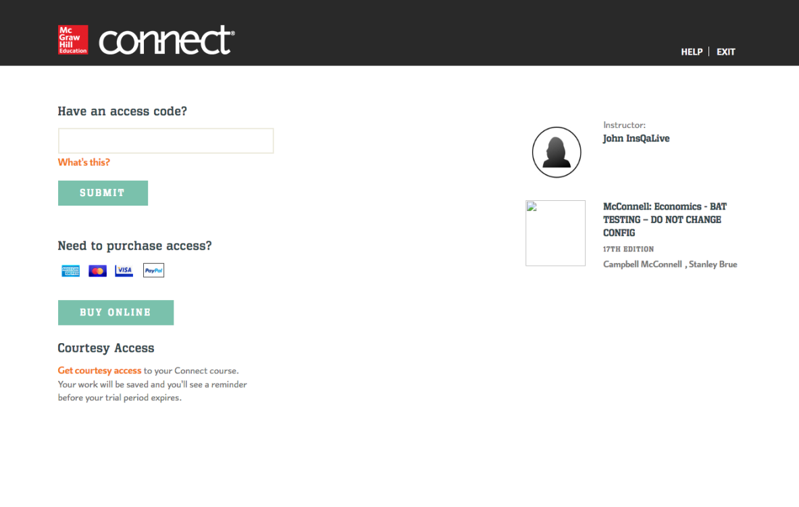

Step 9: Click Confirm.
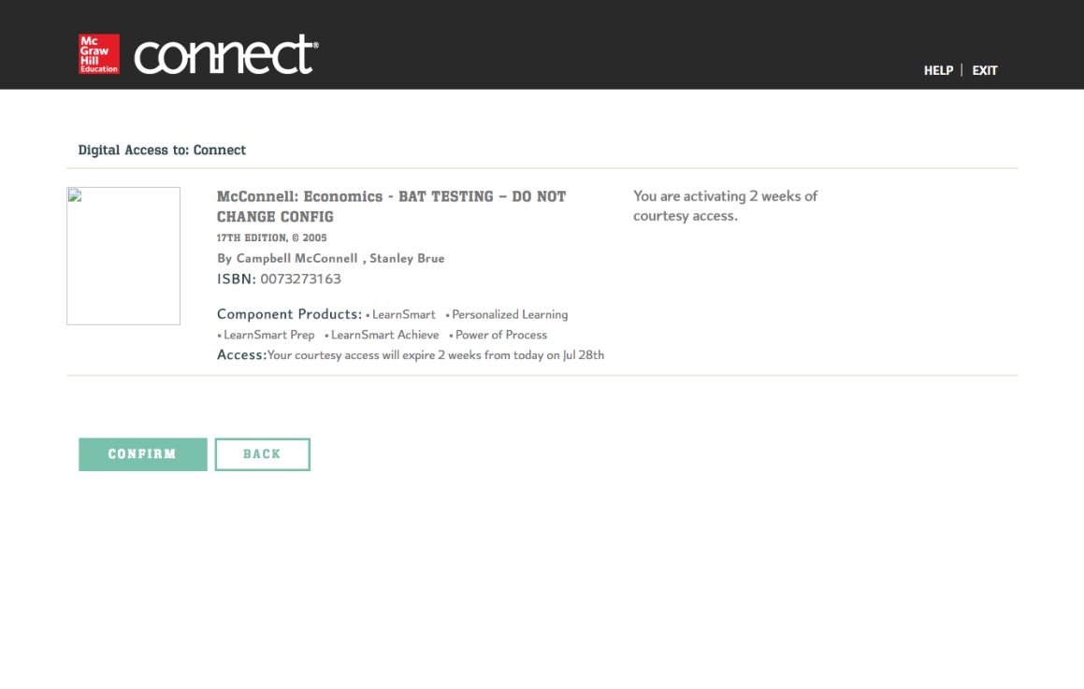

Step 10: Click GO TO CONNECT to finish Connect registration and pairing process.
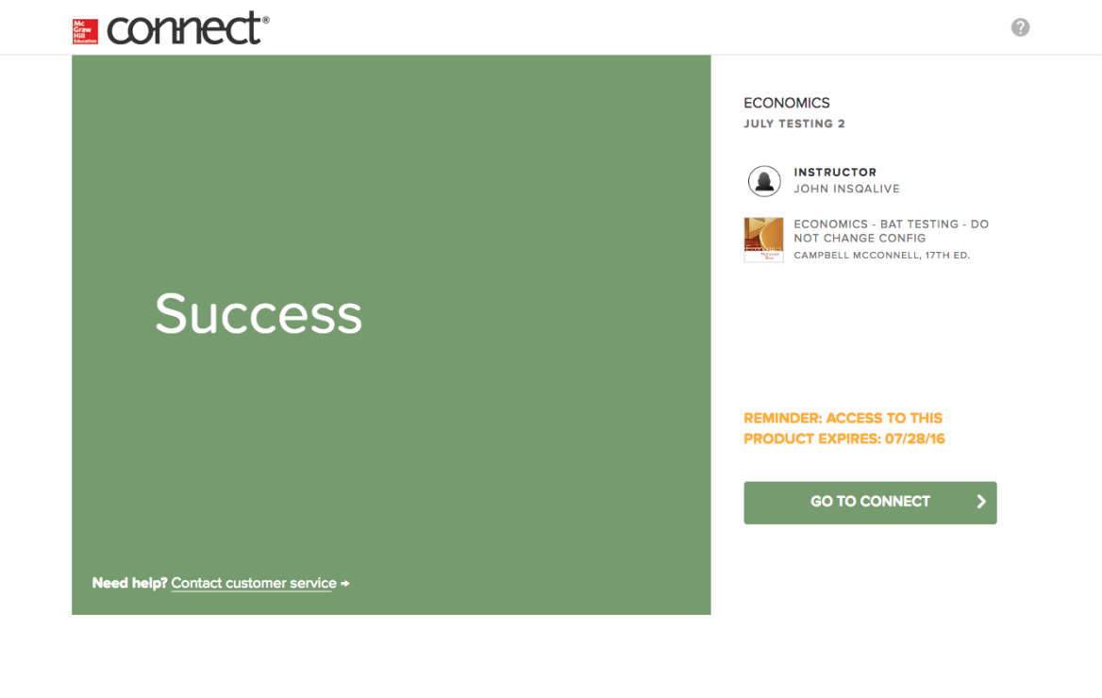

After a student creates and pairs their Connect account (via Deep integration), he/she will be able to begin accessing Connect assignment links via their Canvas course (located under Assignments via Canvas).
